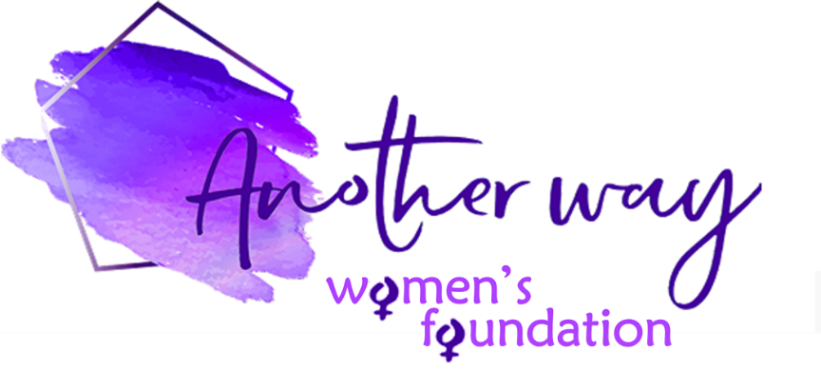

£1000 for 1000 Words Grant – Application Form

Name:

Email:

Phone number:

Name of organisation:

Address or location of project:

Registered charity number (if applicable):

___________________________

In 1000 words max, tell us about your idea, how the £1000 grant would be spent and how you think it will positively impact on women in your local community…

Would you be willing to allow Another Way Women’s Foundation to detail your organisation with images and a story on our website? (the intention would be to raise further awareness of your cause) – tick box: YES NO

Whilst we would like to respond to all applicants in person this might not always be possible and Another Way Women’s Foundation reserves the right to decline applications without reason.
Unsuccessful applicants may apply again – please check our website for the next deadline.
COMPLETED FORM SHOULD BE EMAILED TO: hello@anotherwaywf.org

