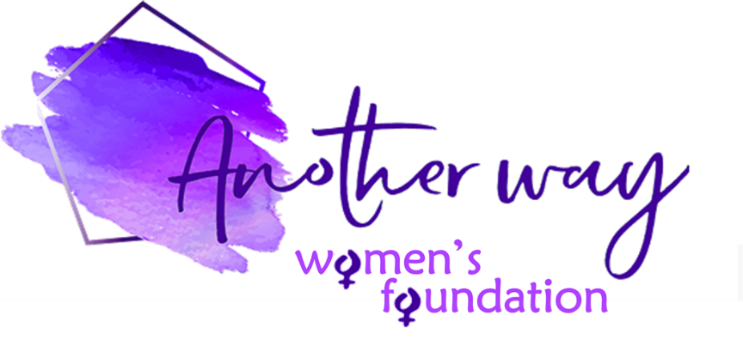

Another Way Women’s Foundation Grant – Application Form

Name:

Email:

Phone number:

Name of organisation:

Address or location of project:

Registered charity number (if applicable):

___________________________

Tell us about your organisation – include website/social media links if you have them:

Tell us about the project:

How much money would you like to apply for?
(Grants are normally in the region of £500 to £5,000 but can be up to £10,000 in exceptional circumstances)

How do you envisage this grant having a long term positive impact on women in your local community? (400 words max):

Explain in detail how this money would be spent – please include a breakdown of costs:

What funding have you had up until now? (eg. Government grants, fundraising, private donations, etc – please give details):

What is the proposed timeline for money being spent?

Would you be willing to allow Another Way Women’s Foundation to detail your organisation with images and a story on our website? (the intention would be to raise further awareness of your cause) – tick box: YES NO

Whilst we would like to respond to all applicants in person this might not always be possible and Another Way Women’s Foundation reserves the right to decline applications without reason.
Unsuccessful applicants may apply again – please check our website for the next deadline.

COMPLETED FORM SHOULD BE EMAILED TO: hello@anotherwaywf.org

